**­­**

**NEWS**

**Easier Operation, Smarter Alarm: Dahua AirShield Redefines User-Friendly Experience**

May 16, 2025 / Hangzhou, China. Dahua Technology, a world-leading video-centric AIoT solution and service provider, has launched an upgraded version of the AirShield security system, designed to enhance security with innovative technology and user-friendly features. This new version emphasizes improved ease of installation, connection, configuration, usage, and maintenance, providing a more efficient and stable solution for installers, ARCs, and end-users.

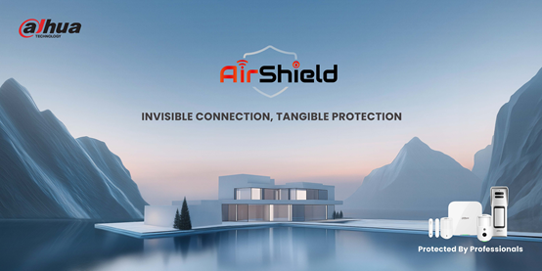

**Convenient and Effortless Installation**

To facilitate installation, the full range of AirShield products is designed with mounting backplates, allowing the devices to be easily attached via a snap-fit mechanism. With the exception of certain individual products, most devices are equipped with built-in batteries, which eliminates the need for signal and power lines, significantly reducing installation complexity. Furthermore, users can quickly identify the optimal installation angle and height with the help of PIR-Cam's snapshot function.

**Connecting Devices with Ease and Flexibility**

Powered by advanced two-way RF communication technology, Dahua AirShield enables rapid single or batch pairing of wireless peripherals to hubs, ensuring instant system integration. It also enables cross-system connectivity, which allows seamless interaction with CCTV and VDP systems within the same LAN for data exchange without additional wiring.

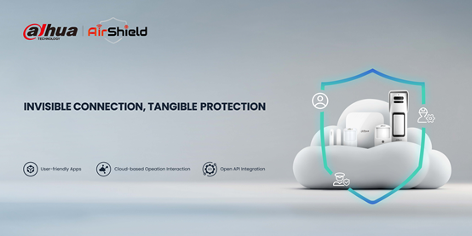

**Simplified Configuration for Quick System Setup**

With AP Mode, users can flexibly configure the hub network with minimal reliance on onsite network environments, dramatically streamlining deployment processes. Additionally, both users and installers can easily configure device parameters via a user-friendly mobile app. To further enhance efficiency, the system supports the batch addition of alarm panels and allows for the backup of existing configuration parameters, which can be seamlessly imported into new devices with just one click.

**User-Friendly Operation for Seamless Management**

In addition to common arming/disarming methods, the AirShield system also supports arming and disarming via SMS, Android VTH, NVR, and dry contact signals, catering to multi-scenario demands. Users can manage the system remotely via DMSS, while installers and ARCs can use DoLynk Care for efficient system management. For instance, ARC clients using SIA integration can remotely control devices upon receiving user requests, significantly improving their alarm service efficiency.

**Smart Maintenance for Long-Term Reliability**

With its cloud-based upgrade, Dahua AirShield allows for remote updates to both panels and wireless peripherals. This enables users to access new features without the need to replace their devices, significantly reducing upgrade costs. Furthermore, installers can utilize the "Health Diagnosis" feature to swiftly detect faulty devices and implement targeted solutions.

Dahua AirShield empowers installers with simplified deployment, enables ARC to deliver faster, more accurate emergency responses, and provides end-users with intuitive, reliable protection—redefining value across the security system. Moving forward, we are committed to full cloud integration and AI-driven intelligence, minimizing false alarms while advancing proactive threat prevention.

_______________________________________________________________________________

***About Dahua Technology***

*Dahua Technology is a world-leading video-centric AIoT solution and service provider. Committed to enabling a smarter society and better living, Dahua has deployed its products, solutions, and services in 180+ countries and regions, covering transportation, manufacturing, education, retail, banking & finance, energy, environmental protection and various industries. The company has more than 23,000 employees, with over 50% of R&D technicians. Focusing on technological innovation, Dahua has established five major research institutes, with annual R&D investment accounting for approximately 10% of its sales revenue. The company continues to explore emerging fields based on in-depth insights and layout of AIoT, and has extended its innovative businesses including iRAYPLE, Pixfra, Waythcan, Wisualarm, Dahua Memory, etc. In line with its core value of “Customer Success, Employee Achievements”, Dahua strives to provide the market with excellent quality and service, create more value for customers, and proactively contribute to a safe, low-carbon, beautiful and harmonious world.*

*To learn more, visit the* [*Dahua*](https://www.dahuasecurity.com/newsEvents/blog) *Blog or follow us on*[*Facebook*](https://business.facebook.com/DahuaHQ/)*,*[*LinkedIn*](https://www.linkedin.com/company/dahua-technology/)*,*[*YouTube*](https://www.youtube.com/user/DahuaTechnology)*and*[*Twitter*](https://twitter.com/DahuaHQ)*.*

***Media Contact***

[PR_Global@dahuatech.com](mailto:PR_Global@dahuatech.com)